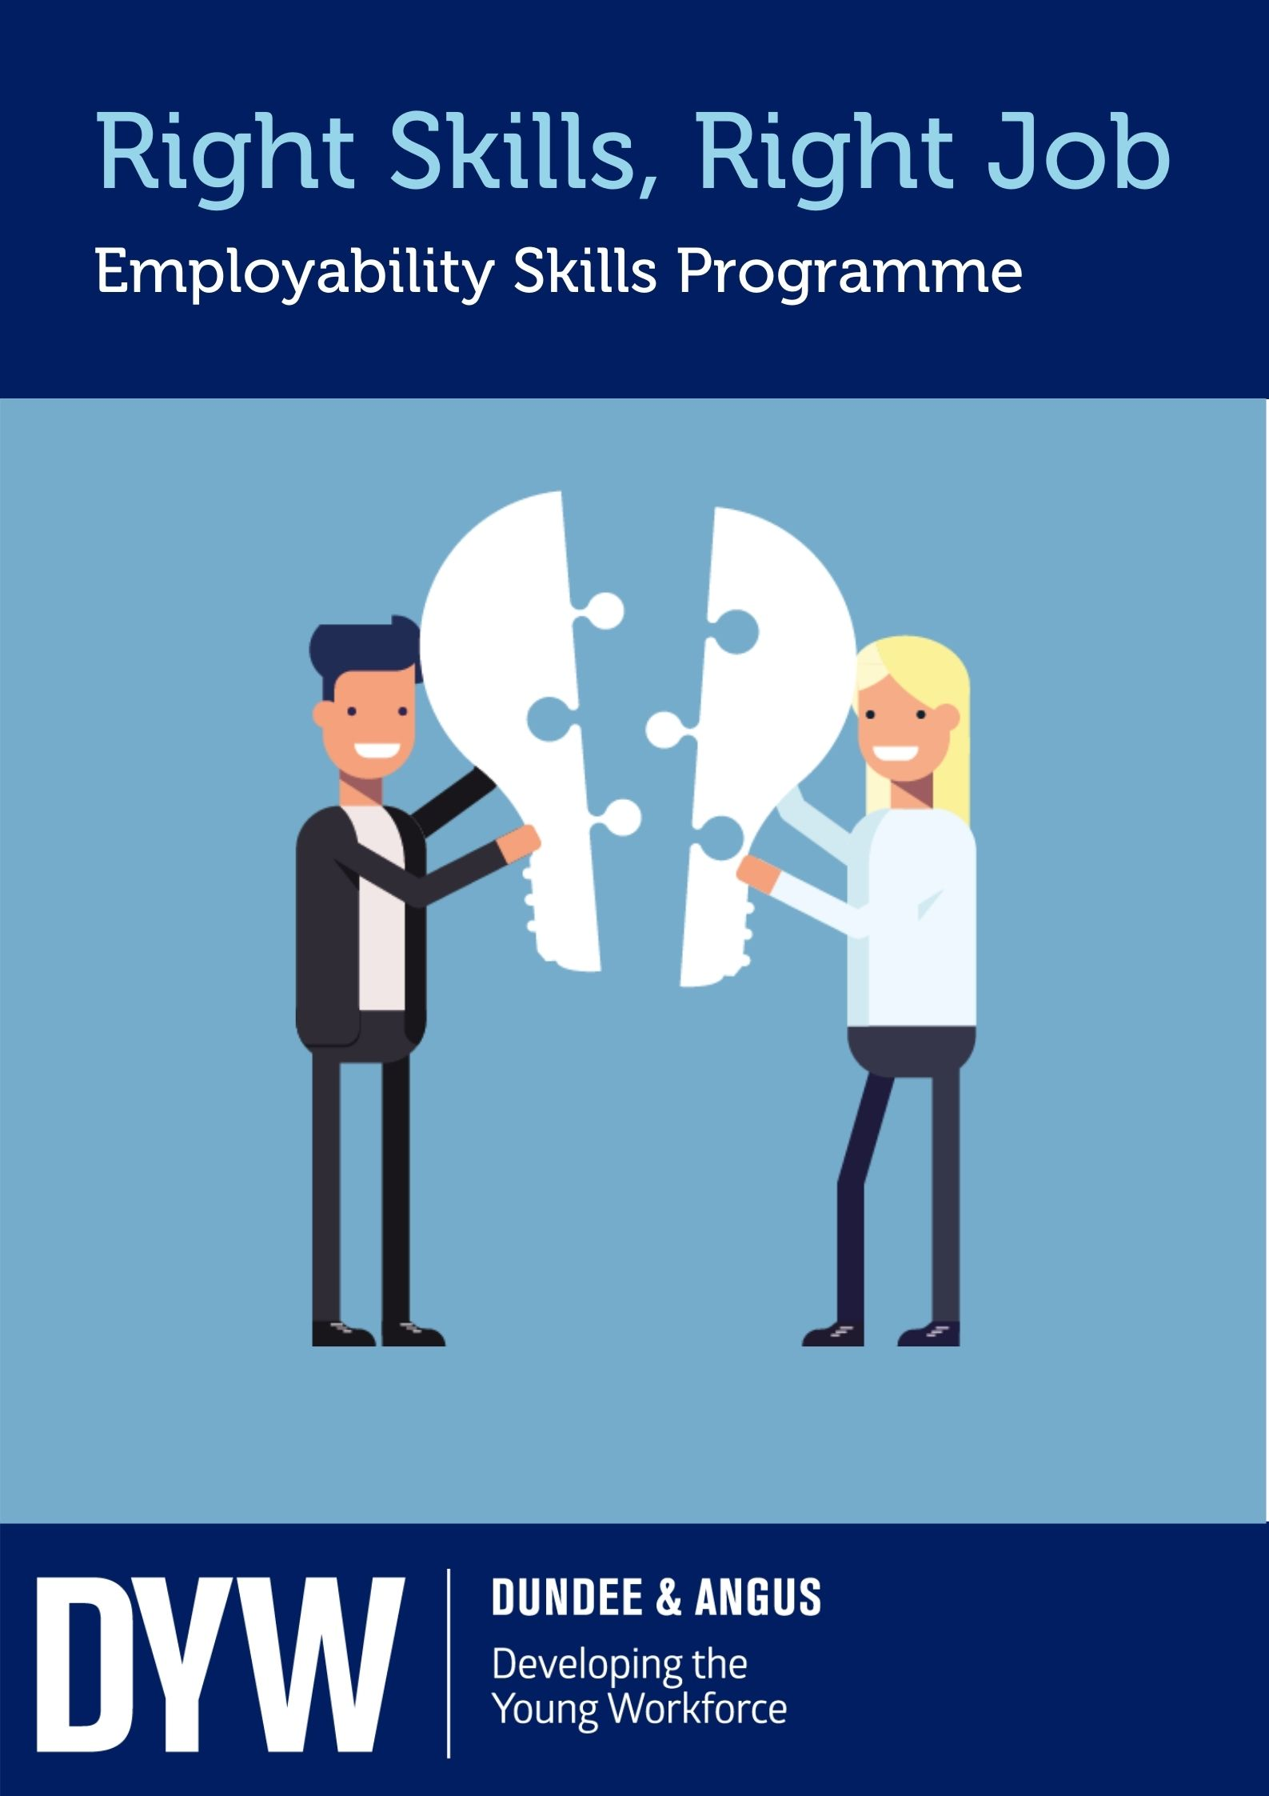

Right Skills I Right Job

Employability Skills Programme

Name:

Class:

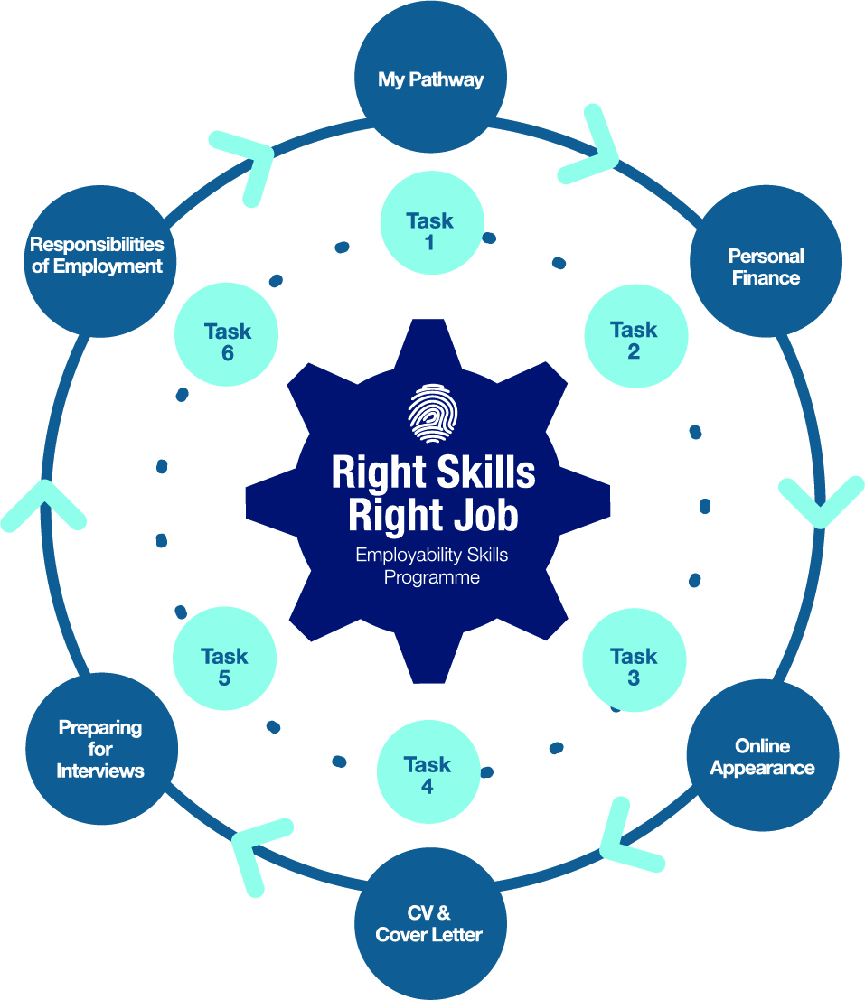

Right Skills | Right Job

Introduction

Right Skills | Right Job is an employability skills programme aimed to help prepare pupils transition from school. Delivery will be 5 employer led sessions, where pupils will cover topics including My Pathway, Personal Finance, Online Appearance, CV and Cover Letter and Preparing for Interviews. Following the mandatory tasks there will be an optional further one to complete. The programme is designed to provide transferable skills, build confidence, advance digital skills, and give pupils an insight into the world of work.
My Pathway
Personal
Finance
Online
Appearance
CV &
Cover Letter
Preparing
for
Interviews
Responsibilities
of Employment

How it works?

Individual businesses sourced by DYW Dundee & Angus will deliver a virtual session on one of the five topics. Each business will tailor the lesson to suit their industry making this a unique experience for pupils. Pupils take back what they have learnt during the session and complete the relevant task in the classroom to evidence their knowledge and understanding. Participating in the programme, pupils will have created a portfolio of work, however on completing the Responsibilities of Employment unit they will be able to use this as evidence to use towards obtaining a full SQA Employability Award. In addition, if the pupil has a work placement, it is possible to use the evidence generated from the RS|RJ programme to gain a Steps to Work Award.

Benefits

Lifelong learning
Builds confidence
Receive insight into the world of work
Learn about variety of routes into employment
Employability skills
Alternative pathways #NoWrongPath

3
Advancement of digital skills

Right Skills | Right Job

My Pathway
Within every business sector, there are various job roles available each requiring different skills, qualities, and qualifications. Choosing what you want to do is not always an easy task, but you should always choose something that you like and what suits you. Everyone is different and therefore your journey through school into employment will not be the same as anyone else. On leaving school there are many options available, e.g. college, university, employment or training. It is important to remember there are alternative routes into employment available depending on your individual career choice, qualifications, and career aspirations.
Making realistic and informed career choices should not be rushed; you need to understand and consider the different options and routes available. Many career pathways can include the following:

- Apprenticeships - Foundation, Modern and Graduate
- Volunteering
- University
- Work Experience Placements / Internships
- Full-time or part time education e.g. studying further qualifications, College- NC, HNC, HND, etc.

Pupil Task 1

Choose a career area that you are interested in. For example, Tourism, Manufacturing, Construction, Engineering, Digital, Health and Social Care etc.

Select one job role in a career area that you would be interested in following as a future career, matching it to your skills, strengths and interests.

You may find the following websites useful; www.myworldofwork.co.uk www.planitplus.net
www.dyw.scot

Right Skills | Right Job

Describe what the job role is. Include:

•Main aspects of the job
•Responsibilities
•Reasons why you have chosen this job role

- Referring to your chosen job role, create a mind map to illustrate what career pathway you could take. Your mind map should include:

  - Job title
  - Qualifications required
  - Entry route e.g. degree, apprenticeship, work experience
  - Skills required
  - Your strengths which matches this job role
  - Backup plan

Right Skills | Right Job

Personal Finance

Having a rewarding career should always be your goal but it is also really important that the salary from your career can support your lifestyle.

In the UK around 56% of families living in poverty are working* showing that just because you work, does not necessarily mean that you earn enough to support yourself and your family. Therefore, being financially capable and being able to plan your finances is key to ensuring you have enough money to pay for what you need and to ensure if you are unable to work, that you are still have an income.

Financial capability is linked with improving our knowledge and understanding of our own personal finances. This is a life skill that will help you:
- Make ends meet
- Keep track of your finances
- Plan ahead
- Choose financial products such as a mobile phone contract or credit agreement
- Stay informed about money matters

It is important for you to track your income and expenditure so you can make decisions about what you can afford. Income is used to describe money that you receive on a regular basis and can be made up of wages, bursaries, benefits or any other money that comes to you. Expenditure is used to describe the money that you need to pay out regularly such as bills and living expenses.

Keeping a close eye on your income and expenditure will help you make decisions about what you can afford; it will help you make realistic savings goals and help you avoid making commitments that you can’t keep up with. We can only make ends meet if we understand how much money we have coming in and going out on a regular basis.

It is important to think realistically about your future and the type of life you would like to afford. Early planning of your money can secure your future and avoid financial difficulty.

*Source: https://www.scotpho.org.uk/life-circumstances/income-and-employment/data/working-age-poverty/#:~:text=Income%20and%20employment%3A%20working%2Dage%20and%20in%2Dwork%20poverty&text=Before%20housing%20costs%2C%20530%2C000%20working,costs%2C%20this%20increases%20to%20640%2C000

Pupil Task 2

For this task, assume that you are 17 years old, living at home, working full time (37 hours a week) and earning the National Minimum Wage for a 16-17 year old (£4.55 per hour). Due to the level of pay, you wouldn’t be required to pay any tax. Your take home pay is £168.55 per week. For this first task have a think about how you will spend this. Here is an example of how your wages could be spent:

Right Skills | Right Job

Expenditure (Weekly)
Board/Lodgings | £50.00 per week | Gym/Hobbies | £10.00
Weekly bus ticket | £13.50 per week | Hair, beauty/toiletries | £10.00
Lunches/Eating Out | £20.00 per week | Savings | £10.00
Mobile Phone | £10.00 per week | Socialising | £10.00
Clothing | £10.00 per week | Driving lesson | £25.00

Using the weekly income figure of £168.55, thing about what you would spend your wages on. Think about what you spend at the moment. What items would you cut back on or like to increase. If you had to buy a larger item like a new laptop, how would you manage that? Think about options like saving some money every week or buying second hand. Make a list here to create your own weekly budget.

While you are living at home paying board is important for lots of reasons. The cost of keeping a home can be really expensive and any contribution you can make will help a lot. This will also give you a sense of financial responsibility, helping you to learn to manage your own spending choices and preparing you for a time when you may want to move out. Depending on the arrangement you come to at home, you may pay less or more than the figure in the table. Just remember, while it may seem frustrating to begin with, it will be a lot cheaper than keeping a property of your own.
- Your first flat
Picture yourself a few years from now. You might have given some thought to the career you want and know how much the salary is. You might be a college or university student for several years, working part time. You might decide to learn a trade, starting off on an Apprentice wage. Whatever your goals, it’s important to remember that it will take time to get there. Let’s imagine you are 19 years old and working full-time (37 hours per week). You earn the Real Living Wage which is £9.50 per hour. It is important to understand that because of tax and National Insurance contributions your take home pay will often be less than the gross pay.

Right Skills | Right Job

Example of deductions from Gross Pay
 | Yearly | Monthly | Weekly
Gross Income | £ 18,278.00 | £1523.17 | £351.50
Pension Deductions | 601.90 | £50.16 | £11.58
Taxable Income | £5176.10 | £431.34 | £99.54
Tax paid | £1014.37 | £84.53 | £19.51
National Insurance paid | £1053.36 | £87.78 | £20.26
Net Take Home Pay | £15,608.37 | £ 1300.70 | £300.15

If you are paid monthly, your take home pay will be £1,300.70. You can see the calculation online by clicking here – salary calculators are a really useful way to work out what you will be paid when starting a new job.
You are living alone in a privately let 1 bedroom flat, paying £450 per month in rent. You have to travel by bus each day for work and sometimes take taxis when travelling late at night. You receive a Single Person’s Discount on your Council Tax but are still required to pay £87 per month. Use the monthly budget planner below to plan what you need to spend money on.
Monthly Budget Planner

Expense Type | Detail | Amount
Rent/Mortgage
Gas and Electric
Council Tax
TV Licence
TV and Broadband
Mobile Phone
Travel Costs
Food
Clothing / Misc
Other
 | Total

If you have money remaining you now have the choice of what you spend it on, or you could save some.

Expense Type  (e.g cinema, socialising) | Detail | Amount
 | Total

Right Skills | Right Job

How much money are you left with from your monthly take-home pay after accounting for essential and non-essentials?

If you do not have anything left, you would need to amend your Monthly Budget Planner.

The Expenditure Menu

You can use these figures or work out your own more accurately by researching online or asking friends and family. The following figures are monthly estimates for a single person, living alone.
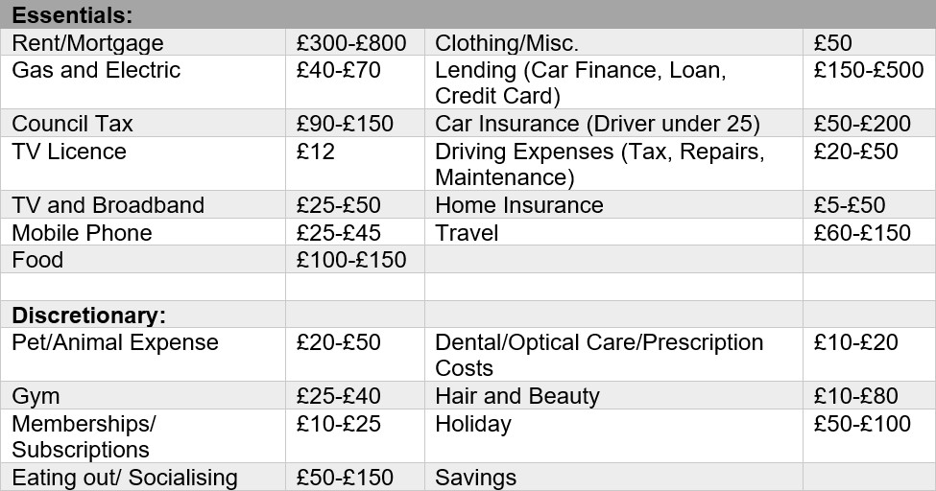

- Living the Dream

Imagine yourself in 20 years’ time – how do you hope you’ll be earning your income? What type of work do you want to do, and do you know how much you might get paid to do it?
Think of your career goal and identify a job you could see yourself doing. Maybe the job you’ll be doing in twenty years doesn’t exist right now. Maybe you’ll want to be an inventor or an entrepreneur.
For career inspiration see DYW Dundee & Angus Career Inspiration Series or visit My World of Work
Think about and research that goal.
What type of salary is typical for that job role?
Repeat exercise 2 based on the typical salary for your chosen job. Remember that your living expenses may be higher depending on where you choose to live.

Right Skills | Right Job

Expense Type | Detail | Amount
Rent/Mortgage
Gas and Electric
Council Tax
TV Licence
TV and Broadband
Mobile Phone
Travel Costs
Food
Clothing / Misc
Other
 | Total

Right Skills | Right Job

Online Appearance

Social Media is a key player when applying for jobs today. Facebook, Twitter, and Instagram allow employers to see who you are outside of your application. According to a 2017 survey, 70% of employers use social media to screen candidates before hiring*. Therefore, it is important to create the right impression with potential employers.

To be taken seriously in a professional world, you should be careful what you share online with the world. Offensive statuses, inappropriate profile pictures, distasteful comments and out of date profiles could affect your chances of employment before you reach an interview.

You should consider using your online appearance in a positive way as a self-marketing tool to demonstrate your strengths, shine a positive light on unique hobbies, and highlight your values, skills, and experiences to potential employers.

There are many different forms and types of social media and no matter what platform you use; it is important to be vigilant and to not post anything you would not mind an employer or potential employer seeing. Make sure you check your privacy settings.

What employers want to see on Social Media:

- Correct spelling and grammar
- Statuses/photos reflecting true interests
- Examples of education and work experience
- Demonstrate your strengths not weaknesses
- Volunteering/charity work
- Clubs and societies

What employers do not want to see on Social Media:

- Sharing your political views
- Debates over controversial topics
- Making references to illegal drugs and bad language
- Complaining about your teacher/school/job/boss
- Using texting language
- Posting tasteless comments
- Posting photos with alcohol
- Unprofessional profile pictures
- Allowing friends to post improper comments

* https://www.careerbuilder.com/advice/social-media-survey-2017 8

Right Skills | Right Job

Pupil Task 3

Look at the ‘dummy profiles’ attached of Twitter. Identify 3 positives and 3 negatives for each profile and explain the reasons why.
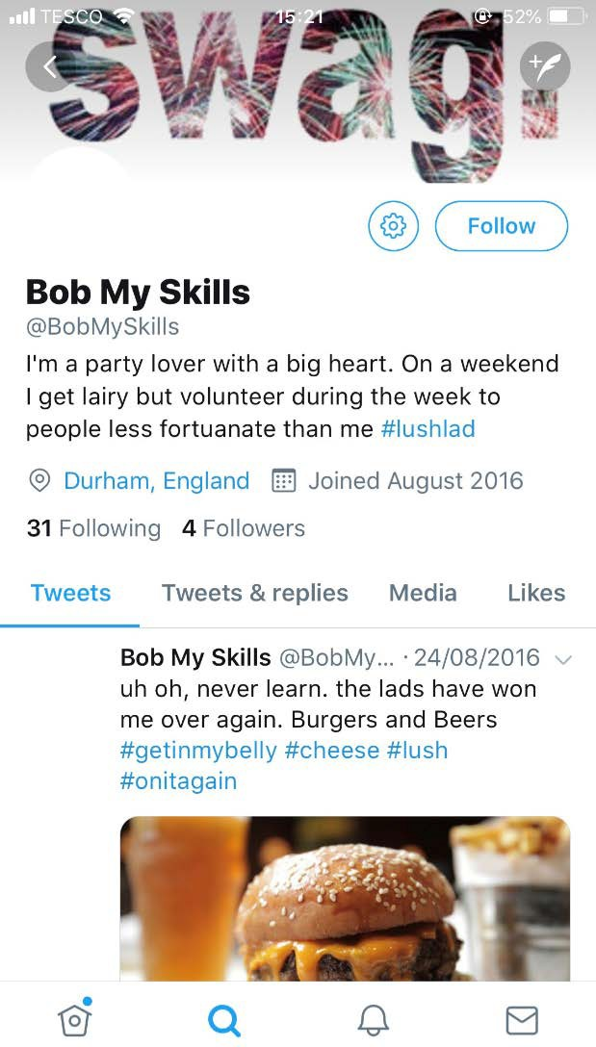
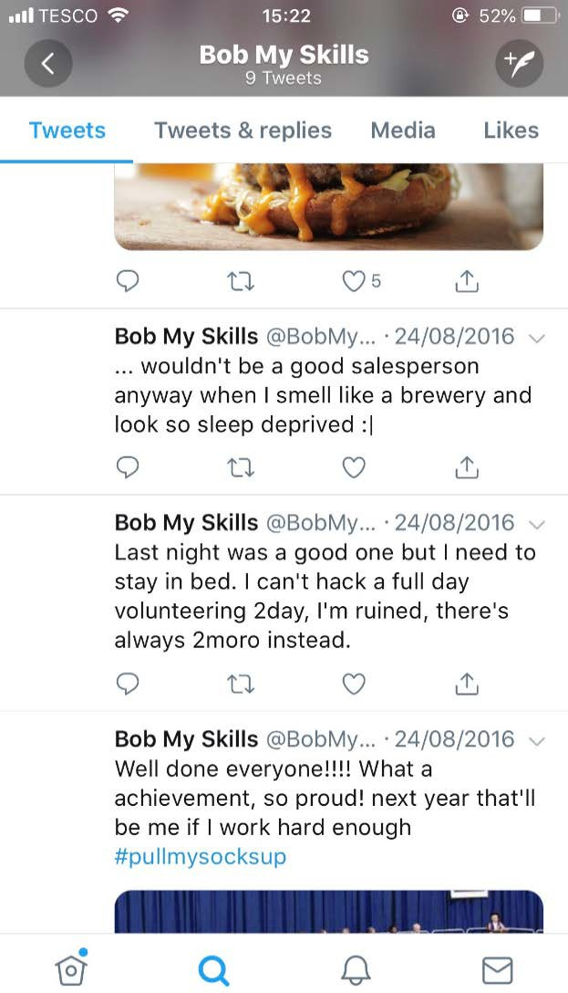
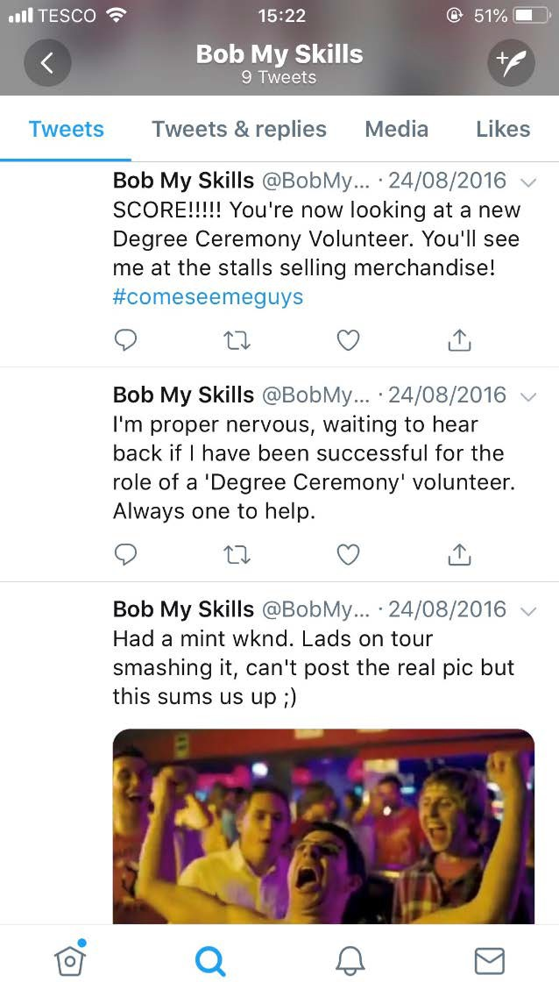

Positives

1.

2.

3.

Negatives

1.

2.

3.

Right Skills | Right Job

Identify positives and negatives relating to your own online appearance. In addition, identify 3 positive interests or accomplishments that you could post on Social Media personal to you.

Positives

Negatives

1.

2.

3.

Right Skills | Right Job

CV and Cover Letter
When applying for a job, you may be asked to provide a CV (Curriculum Vitae – Story of your life) and Cover Letter. Your CV should outline your educational history, relevant experiences, and your skills. When tailoring your CV, you may be able to use the job specification (a list of skills and experiences the ideal candidate will have) which is sometimes included in the job advert.

If you need to complete an online application for a role, this will include personal details, your skills, abilities, knowledge, and experience. You may also be required to complete several application questions or an online assessment which are designed to find out whether you have the necessary skills for the role.

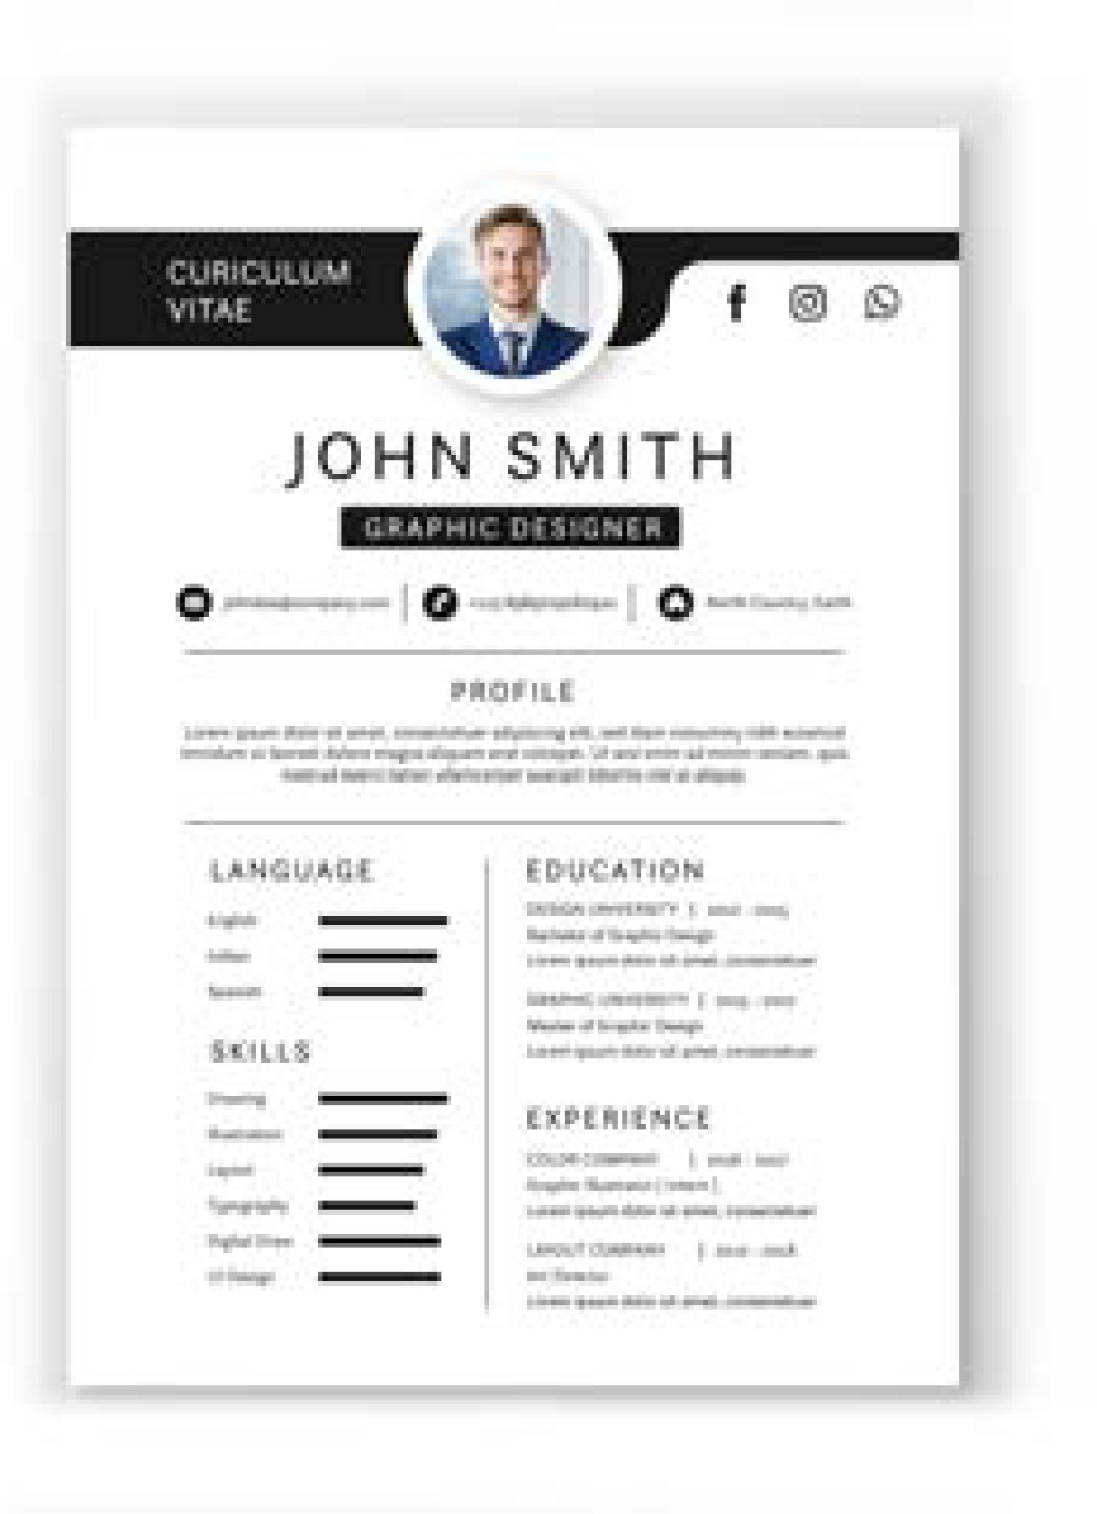

CV do’s and don’ts:

Tips for a good CV:
- Should be no longer than 2 sides of A4
- Do not include your age
- Use an appropriate email address
- Tailored to the job
- Proof-read for spelling errors
- Do not falsify information
- Well laid out and clear to read

- Must be word processed - use black font colour
- Should be 1 - 2 pages on white paper
- Should not have spelling or typing errors
- Use a plain clear font such as Arial or Times New Roman

Pupil Task 4

You will be creating your own CV in My World of Work. Please follow the below steps.

  - Log into My World of Work
  - Go to the drop down 'Getting a Job' and select the option 'CVs and applications' and read the information provided.
  - Next click on the button 'Build your CV now' and read the information
  - Once you have read the information you are ready to begin your CV.
  - To start -click on the button 'Make a CV'
  - Work through the tabs ensuring you save each section as you go.
  - When finished, download your CV, and upload to Glow or copy and
paste onto the next page. 11

Right Skills | Right Job

CV

Right Skills | Right Job

Produce a cover letter based on the job role you looked at in My Pathway. The cover letter should explain your suitability and highlight areas which would make you the best person for the role.

Writing a Cover Letter:

- Usually you would send a cover letter with your CV in response to a job vacancy
- The aim of the cover letter is to outline what you are applying for and your current situation
- It needs to be brief and to the point, drawing attention to relevant parts of your CV but not duplicating it

Optional Task

Answer the following questions which are typically found on an online job application, refer to your chosen job role from My Pathway.

Describe something that you are really proud of, either in school or part of your extracurricular activities.

- What personal qualities do you have that you think are necessary for success within your chosen job role?

Right Skills | Right Job

Cover Letter

Right Skills | Right Job

Preparing for Interviews
Well done you are now at the final stage of the application process. You will be invited to an interview as you have potential and the employer believes you could be a great fit for the workplace.

There are lots of types of interviews including online assessments, telephone, face to face, video, panel, and group. The application process can include up to three of these assessments before you have a face to face interview. Preparation is key! Fail to plan – plan to fail.

Interview Tips

How to prepare?
- Search the company online and collect background information.
- Be sure you know the time, date and location of the interview and the name of the interviewer.
- Prepare what you are going to wear the night before.
- Decide how you are going to get there and what time you need to leave.
- Familiarise yourself with the job advert and person specification, it’s likely you will be asked questions relating to this.

Most common interview questions:
- What can you tell me about yourself?
- What are your strengths and weaknesses?
- Why are you suitable for this role?
- Where do you see yourself in 5 years’ time?
- Why do you want to work here?
- What motivates you?
- Is there anything you would like to ask me?

During the interview:
- Stay relaxed
- Maintain eye contact
- Nod approvingly
- Do not interrupt
- Do not be afraid to ask the interviewer to repeat the question
- Always have at least one question to ask

The STAR model is useful when it comes to answering questions as it provides all the information employers are looking for.
- Situation: What happened and where
- Task: Explain what you were doing
- Actions: Describe what actions you took and the skills you used
- Result: Describe the outcome and what you achieved

Right Skills | Right Job

Pupil Task 5

Describe 3 ways to prepare for an interview which will improve your chances of being successful

1.

2.

3.

  - Prepare answers to:
    - Two good reasons why you are suitable for the job role

    - Your strengths/qualities and skills

    - Identify a weakness and your plans to overcome this

  - Prepare two questions that you could ask the interviewer. 1.

2.

Optional Task
Interview role play: In pairs, assign roles of ‘interviewer’ (student A) and ‘interviewee’ (student B) to practice speaking at an interview. You could use the job roles from Task 1 and prepare suitable questions. Try to answer using the STAR model. 16

Right Skills | Right Job

Responsibilities of Employment Task 6 (A)
Identify how employers will expect you to behave at work and how they should treat you.

To achieve this assessment the following activities must be completed:

- Identify your responsibilities as an employee

- Identify what employers should do to treat you properly when you are in the workplace

- Draw conclusions about the differences between how you behave in the workplace and how you behave in other places you know.

Use the below websites to help access info: www.citizensadvice.org.uk/work/rights-at-work/ www.gov.uk/employment-status/worker
- What responsibilities do you think you have as an employee?

Responsibility 1 –

Responsibility 2 –

Right Skills | Right Job

Identify two things employers should do to treat you properly in the workplace. You may give examples from: behaviour, employment contract, health and safety, etc.

Example 1 –

Example 2 –

Task 6 (B)

Differences in the workplace

1. Read the following passage and answer the questions that follow.
There are many rules and regulations at work. You usually sign a contract when you first start work. This gives you your terms and conditions of work. It explains how you must behave, the work you must do and how long you must work. For example, you may think it is acceptable to swear at home but find that in most places of work it is unacceptable and may eventually lead to dismissal. The contract also covers health and safety and equal opportunities legislation that you must follow. Some young people smoke and drink alcohol with their friends but know that would be breaking health and safety regulations if they did this at work. If you make sexist or racist remarks to others at work, you could be dismissed. At college or school, you may not always have followed instructions but if you do this constantly at work you may get fired. At home you can wear casual clothes but in some places of work you may have to be dressed smartly or wear a uniform with a company logo or wear a hard hat and steel toe capped boots.

Using information in the passage give two possible differences between work and your home life and other places.

Difference 1 –

Difference 2 –

Right Skills | Right Job

Task 6 (C)

Identify what might happen to you if you do not act in the way an employer expects. To achieve this assessment the following activities must be completed:

- Identify what could be unacceptable behaviour in the workplace

- Identify what an employer might do if you behave in an unacceptable way

- Draw conclusions about the consequences for you if you behave in an unacceptable way

Read the following passage and the answer the questions.

Martin Wood, the manager of WOOD'S joinery firm in Aberdeen was hoping to take some of his joiners to Bulgaria to do a big job in a luxury modern hotel. He was not sure who to take. It was a great opportunity for his joiners as they would be learning new skills and as it was a big contract, they would be paid well. He had spoken to his team of joiners about this.

Steve, Ross, and Frankie who worked for Martin had been given a deadline to fit a kitchen by the end of the week. In the van on the way to the job, they were all talking about going to Bulgaria. Steve pointed out that Martin had not decided who he was going to take yet!
Steve did not like working with Ross and Frankie as the other joiners in the firm had no time for them. They had already had a formal warning from Martin about their poor work output and behaviour. When they arrived at the job, Ross and Frankie decided to muck about in the garden.

Martin the manager made a surprise visit to the job.

He found Steve hard at work fitting the kitchen cupboards. Martin looked out the back-kitchen window and saw Frankie and Ross mucking about with cordless drills in the back garden, Frankie had his drill close to Ross's head and they were both laughing. Ross made a rude sign at Martin and Frankie screwed up his face in a stupid way. Martin sent them both home.

Right Skills | Right Job

Task 2 (C) Questions

Ross and Frankie behaved in an unacceptable way. Identify:

  - A behaviour problem –

  - A health and safety problem –

- What might happen to you if you behaved in an unacceptable way at work?

- How could this affect you in the future?

Right Skills I Right Job

Extra space if required

Right Skills I Right Job

Congratulations!
You have now completed
Right Skills Right Job
Employability Skills
Programme

