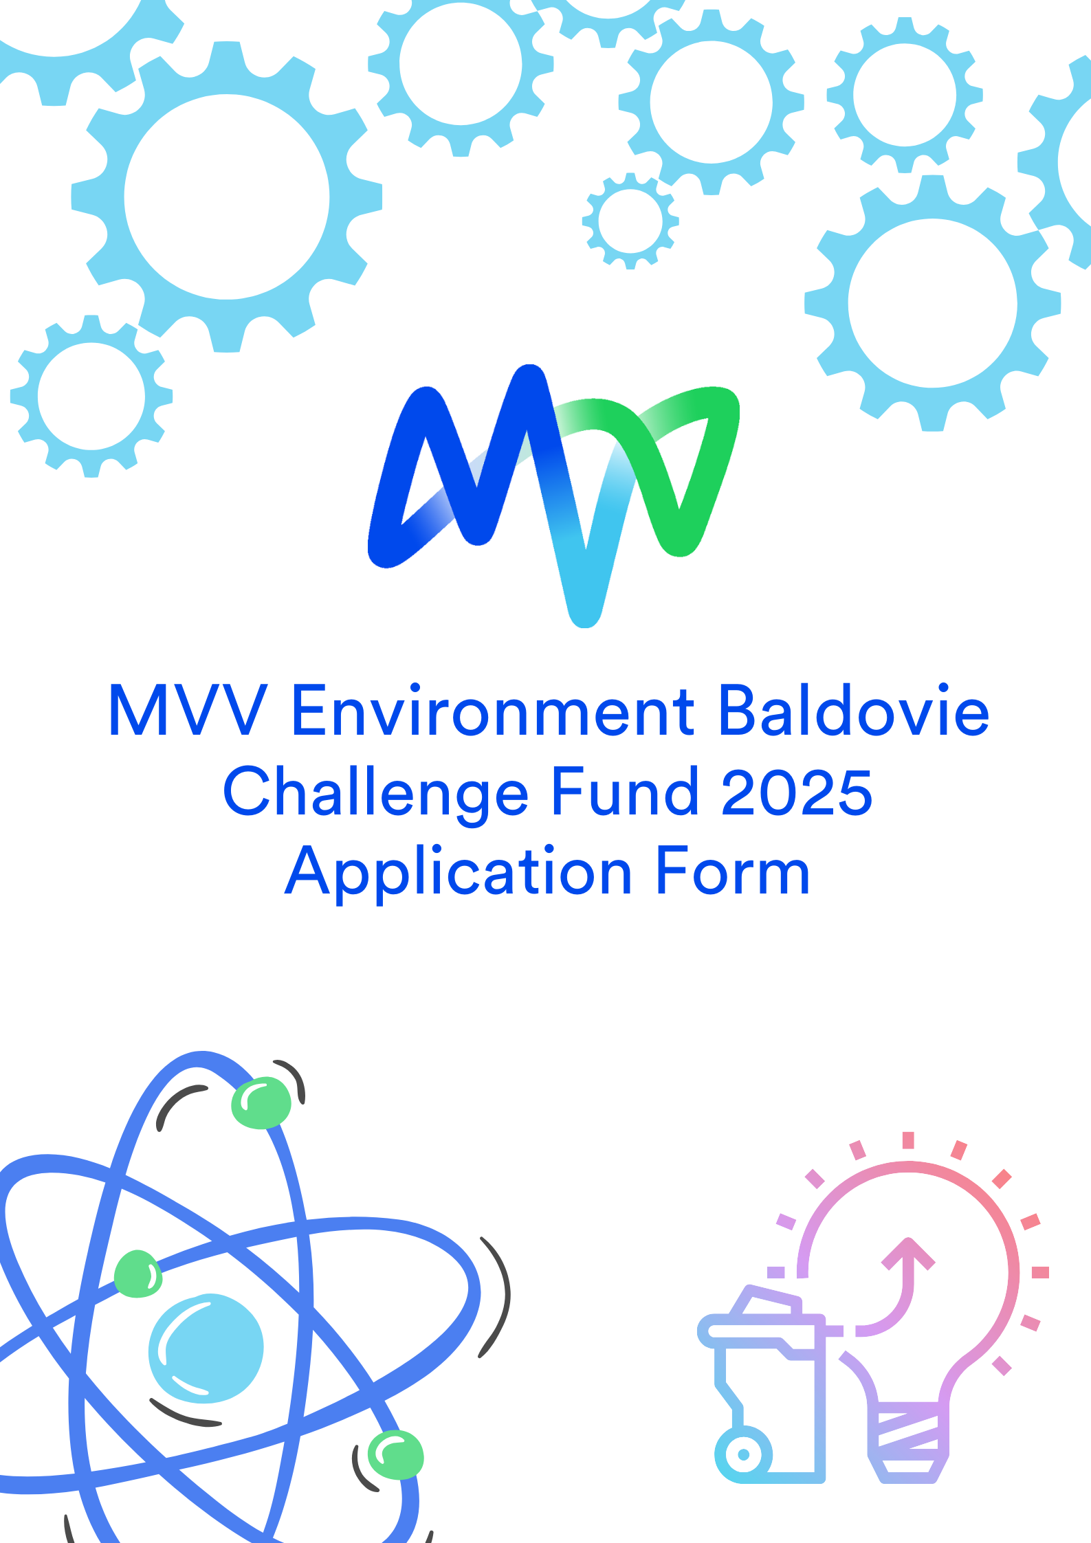
Application
Closing Date: 31st August 2025
Please complete this form with as much information as you can using BLOCK capitals or typed throughout.
- General

Name of school:

Named contact:

Position:

Telephone:

E-mail:

Secondary contact:

Position:

Telephone:

E-mail:

Address:

Postcode:

SECTION 2 – Project/Activity/Programme

Title:
Amount of funding requested: | £

Start date:

End date (if one):

2.1 Project/Activity/Programme details
Please describe the project/activity/programme, who it will impact and why you are applying for funding? (max 200 words)

2.2 How will you make this project/activity/programme happen?
Please provide a plan, including any key dates, location(s), participants, and milestones etc (max 200 words)

2.3 Does this funding support an on-going project/activity/programme?
Will this funding support a current project. If yes, please fill out below. Tell us about previous successes, costs, investment and how this additional money can make it better (max 200 words)

3.0 Project/Activity/Programme Budget
Please provide a balanced budget:
List your project/activity/programme expenditure | £
Total | £

3.1 Other funding sources
Have you applied for any other funding, please let us know:
- Funding confirmed
- Awaiting confirmation
- Conditional on the success of this application (max 100 words)
DECLARATION
By signing this form, I agree that:
- The information provided within this form and any document(s) attached to this form, are correct to the best of my knowledge and belief.
- If required, a member of the Challenge Fund Committee may contact me for further information to help with the decision-making process.
If this application is successful, I agree that:
- MVV Environment Baldovie, Dundee City and Angus Councils may use details of any award made in any of their publicity material.
- Any insurance liabilities that may arise from the activities funded will remain the responsibility of the applicant – you are advised to ensure appropriate cover is in place.
- Any payment made will be returned in full if the project does not take place within a year of the original start date proposed, if the funds are not used as described or, if the evaluation form is not submitted within the agreed time as advised with your award.

Signature:

Print Name:

Position:

Date:

SUBMISSION AND CONTACT DETAILS
Please submit completed application form by 31st August 2025 to Sarah Cartmill, Community Liaison Manager, sarah.cartmill@mvvuk.co.uk.

Privacy Statement
Personal data is information about your personal and material circumstances. This includes information such as your name, address, telephone number and e-mail address. In general, you do not need to actively disclose any personal data to use our websites.
When you visit our website, we store the following data in anonymised form: the name of your internet provider, the number of visits you make to our website per day and week, the number of visits per page, the average time spent per page, the number of feedbacks and the website from which you visit us. This data is evaluated to ensure the trouble-free operation of the website and to improve our services.
No personal user profiles are compiled using this data.
If you use our services, we will only collect that data (e.g. your name and address) we need to provide these services. If we ask you for additional data, you provide this on a voluntary basis.
Purpose of processing
We will process (in particular collect, use and store) your data for the following purposes:
- a) To respond to your enquiries, process your orders, or provide you with access to specific information or offerings (Art. 6 (1) b) GDPR).
- b) To protect our legitimate interests and those of third parties, particularly of companies within the MVV Energie Group, also for advertising or market research, to improve services and offerings of customised products, for credit checks, or to investigate or prevent criminal actions such as electricity theft (Art. 6 (1) f) GDPR).
- c) To the extent that you have given us your consent (Art. 6 (1) a) GDPR).
- d) Due to legal requirements to which we as a company are subject, and in particular the requirements of commercial and tax law, the German Energy Industry Act and the German Metering Operation Act. (Art. 6 (1) c) GDPR).
Forwarding of personal data
If we need to do so to process your enquiries or perform our services for you, we will forward the personal data we have collected to the legally permissible extent (e.g. for order processing) to recipients in the following categories:
- Customer support service providers
- Banks, payment service providers, debt collection agencies and legal firms
- IT, postal and other communications service providers
- Other companies within the MVV Energie Group
- Public bodies and organisations (e.g. supervisory authorities, social security agencies, tax authorities, investigative authorities).
Your data will otherwise only be forwarded if you have consented to this in advance. With regard to the consent you may provide to the use of marketing, statistical and preference cookies (see Information about cookies and tracking) and the associated forwarding of data to third parties, we point out that the processing of this data, if such takes place outside the EU or a secure third country, is performed in accordance with the provisions set out in the judgement of the European Court of Justice dated 16.07.2020 (Case C-311/18), the so-called Schrems II Judgement. These include agreeing standard contractual clauses (SCC) with the respective company and reviewing more far-reaching guarantees to ensure that users’ personal data continues to be protected.

